LAB ASSIGNMENTS-4: Spring boot Testing

Lab Assignment: Spring boot Testing

Spring boot provide wonderful support for unit testing and integration testing. In this lab assignment you will write testing for an existing productstore application provided with lab assignment

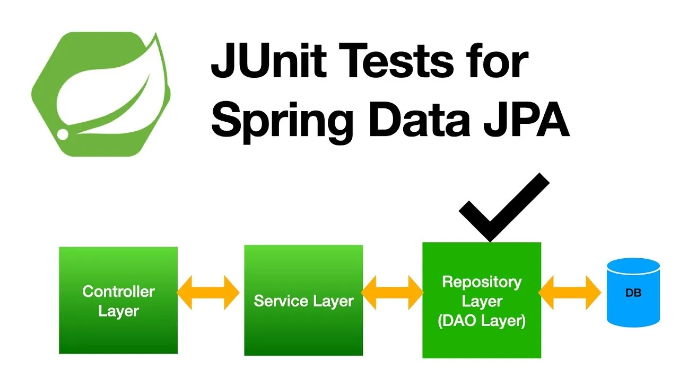
Part1: You need to write test cases for CRUD application for every layer.

Part2: We need to apply Jacoco code coverage to ensure code coverage in our application

Jacoco is an open-source code coverage library for Java distributed under the Eclipse Public License. The library is often used in Java projects to measure the coverage of unit or integration tests. But it's also possible to measure the coverage of any test, using a running application, with the Jacoco agent

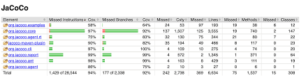

Part 3: We need to apply sonarcube to our application
SonarQube Server empowers developers to achieve comprehensive code coverage, giving them clear visibility into untested areas and offering actionable insights with context. It equips developers by providing a quantitative measure of testing effectiveness

